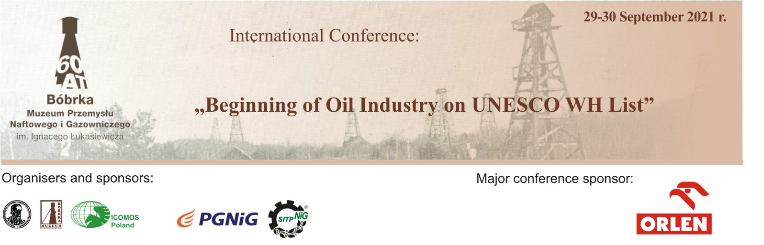
Application for participation

Participant's Name:………………………………………………………………………………………………………

Place of work, mailing address, email, phone …………........................................................................................................
…………………………………………………………………………………………………………………………………………………………………………………………………………………………………………………………………………………………………………………………………………………………………………..

Participation with lecture Participation without lecture

Participation in poster session

Title of lecture/presentation ……………………………………………………………………………………………………………………………………………………………………………………………………………………………………………………………………………………………………………………………………………………………………………………………………………………………………………………………………………………………………………………………………………………………….

Please return the fulfilled application form by June 14, 2021.

Contact persons:
Barbara Olejarz: b.olejarz@bobrka.pl; tel. +48 13 43 33 478, +48 604 948 044
Michał Górecki: m.gorecki@bobrka.pl; tel.+48 13 43 33 588
Marzena Sysak: m.sysak@bobrka.pl; tel. +48 13 43 33 596 - assistance in booking accommodation

e-mail: konferencja@bobrka.pl

